
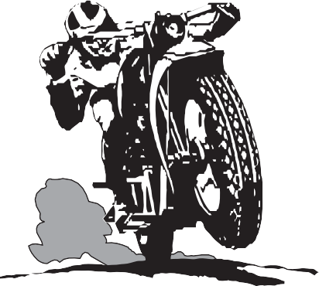

8th COMSTOCK CLASSIC ROAD RUN
OCTOBER 1, 2, 3, 2026
JUNE LAKE, CALIFORNIA

THREE GREAT RIDES
FRIDAY LATE LUNCH/EARLY DINNER
SATURDAY EVENING BANQUET AWARDS & SWAG BAG
Details on the WEB:
www.comstock-amca.org

Host Hotel – June Lake Motel
www.junelakemotel.com
760-648-7547
Further Details Forthcoming

Comstock Chapter AMCA
8th Comstock Classic Road Run
June Lake, California
October 1st thru 3rd, 2026

Rider’s Name:

Address:

City: State: ZIP:

Email: Phone:

AMCA # Chapter:

Year/Make/Model of Motorcycle

Insurance Company/Policy #:

Passenger Name:

Note: All Motorcycles MUST be manufactured before 1991 for this Road Run

Registration is $160 per rider and includes:
One banquet, one linner (lunch/dinner), one t-shirt, ride routes, swag and eligibility for awards.

Rider T-shirt Size: S M L XL 2X 3X Circle one
Quantity and size/s __________________

Extra Banquet - $60 ea. $________
Extra T-shirt - $30 ea. $________

Pre- Registration Only

Total Payment Enclosed $

Payable to: Comstock Chapter AMCA

Mail to: Comstock Chapter AMCA
4279 Muirwood Circle
Reno, NV 89509

